Observation Report

Javascript Algorithm 2

Rodney R. Giray Date: January 6, 2023

Instructor: Alfren James Cabuquit WD37

Level 2 Activity 1 – This level and activity introduce the use of array. In this picture it will print

The value of x in array [1,2,4]

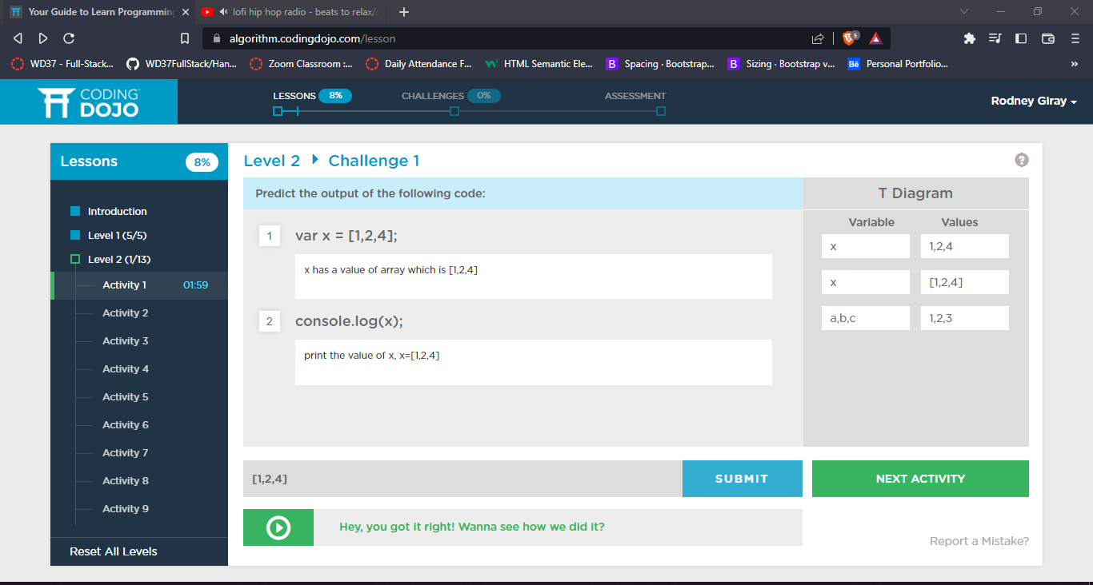

Level 2 Activity 2 – In this image, I noticed the array index is starting to 0 which is x[0] as per the image below

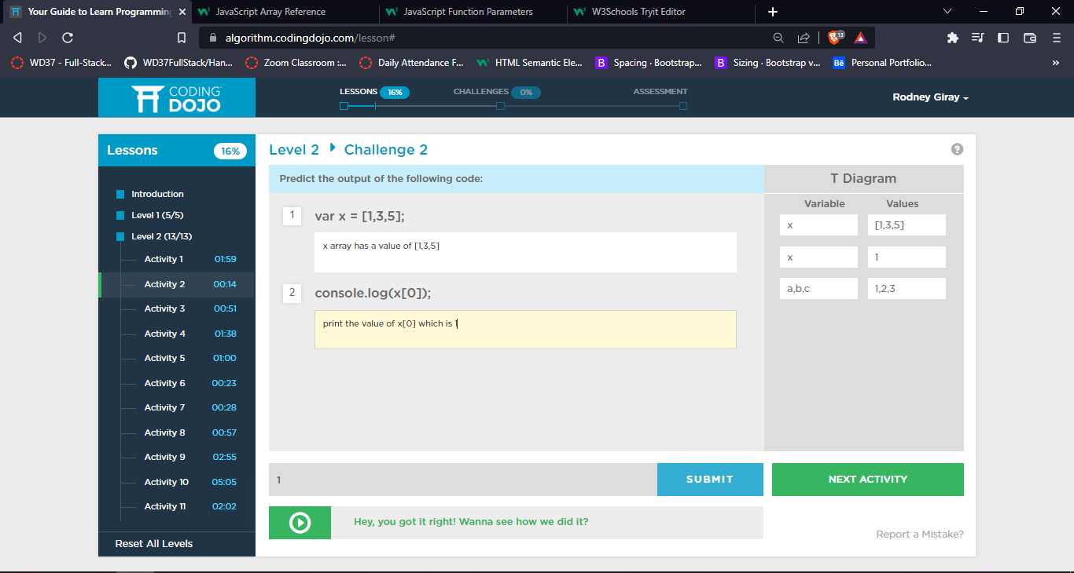

Level 2 Activity 3 – In this image same as the activity to but, this time the index of array is x[1]. That it will print the index of 4.

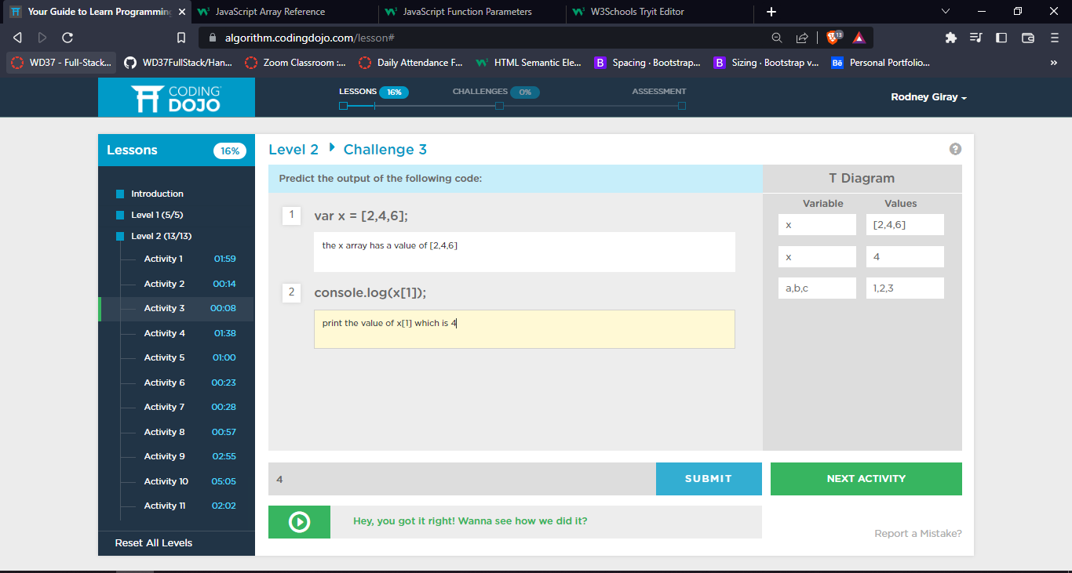

Level 2 Activity 3 – In this image same as the activity no.3 too but, this time the index of array is x[1]. That it will print the index of 4.



Level 2 Activity 4 – In this image, it will print the value of x[2] which is 5.

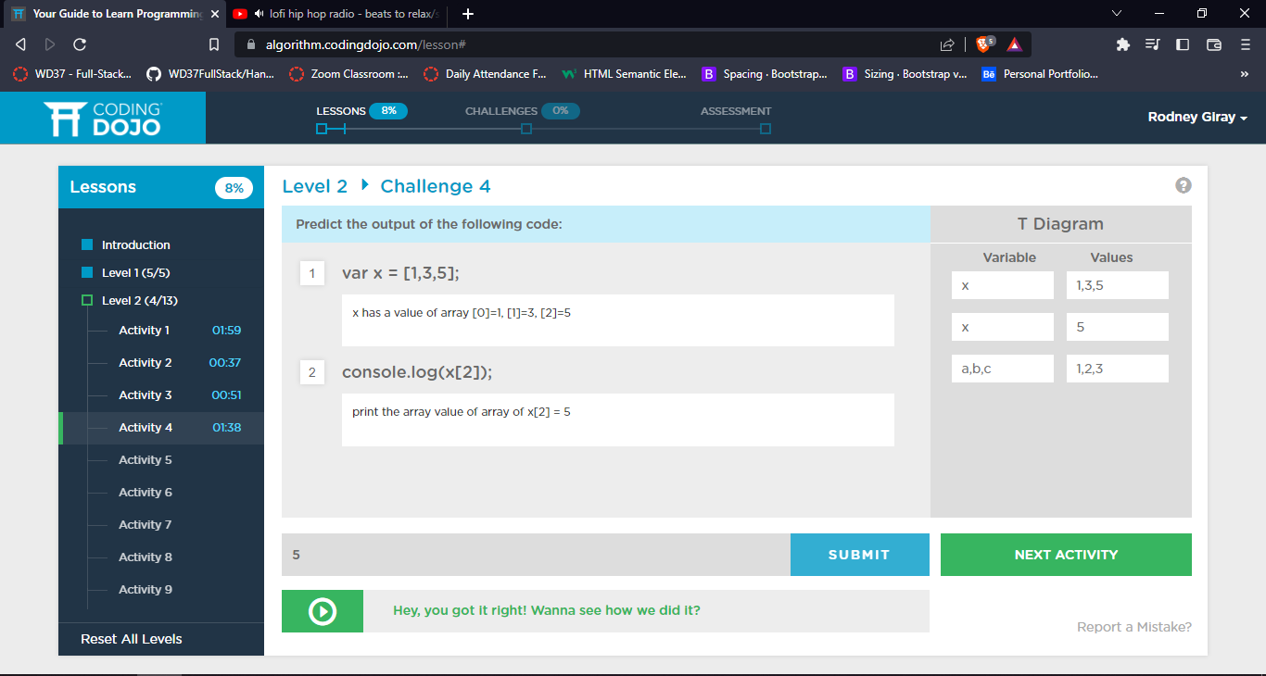

Level 2 Activity 5 – I noticed if the array has a value of decimal like showing in this mage it will select the value.

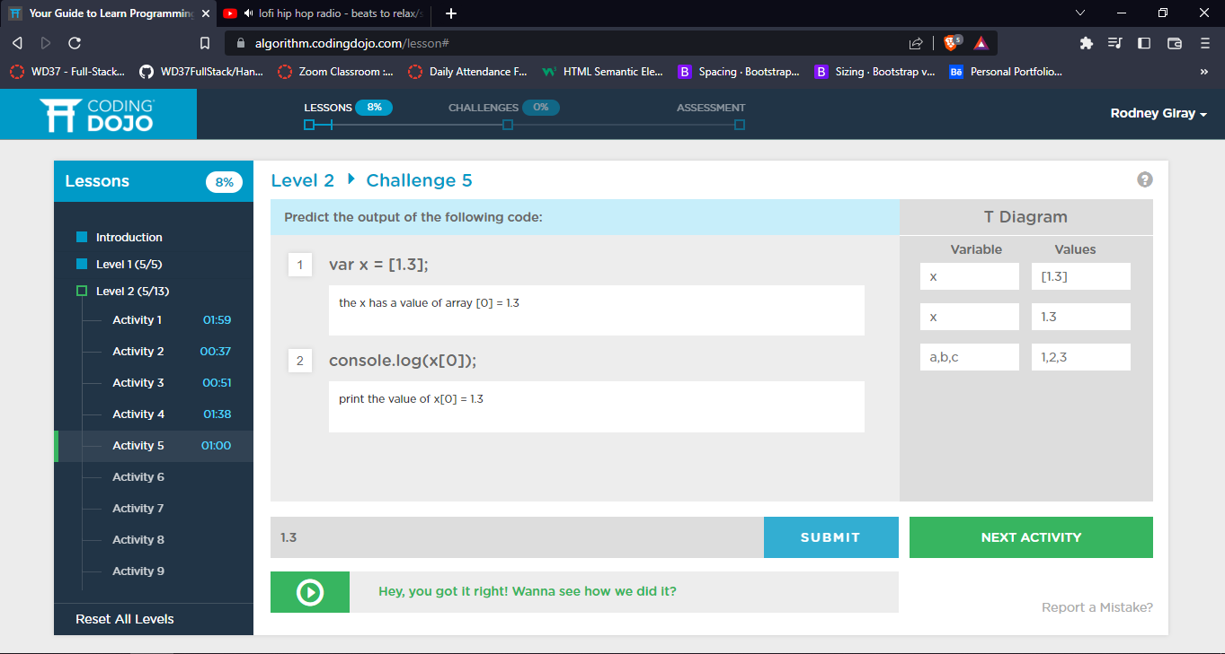

Level 2 Activity 6 – In this activity I noticed that you can change the value of array by getting the value of another array. In addition, the reading of codes will start to right to left. In that case the x[0] will get the value of x[1]

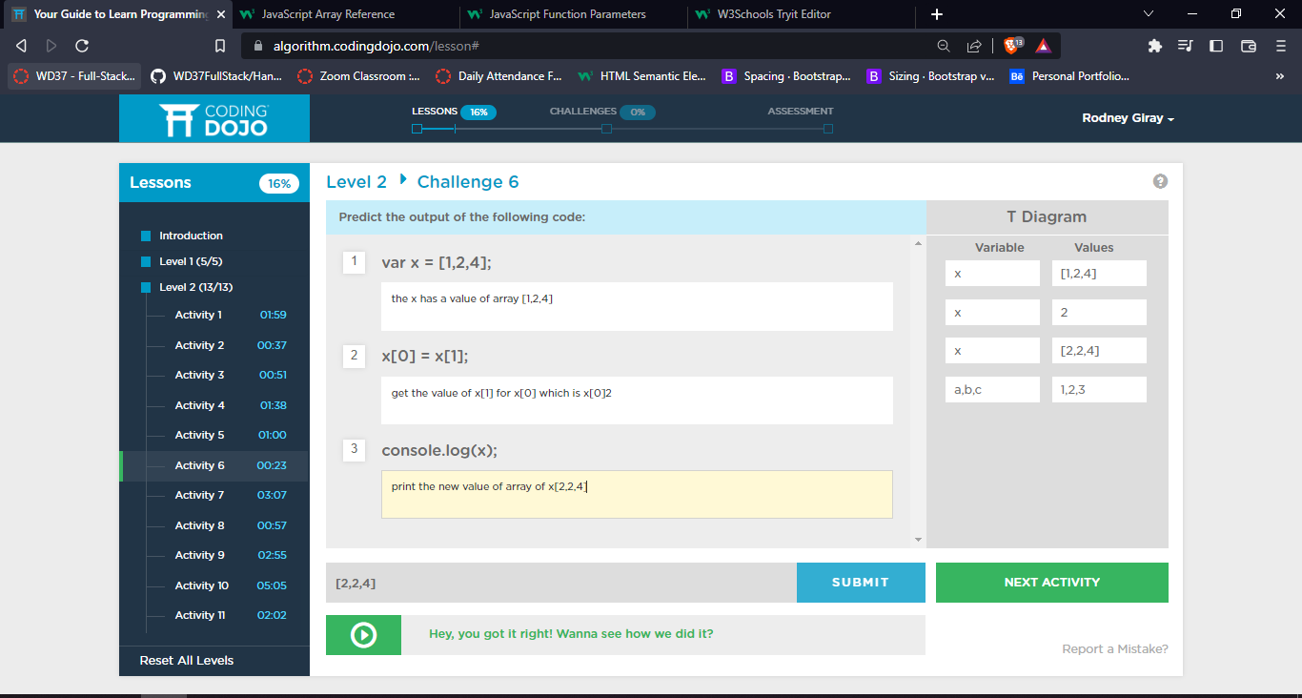

Level 2 Activity 7 – This activity 7 I realized that by using .length will count the index of array

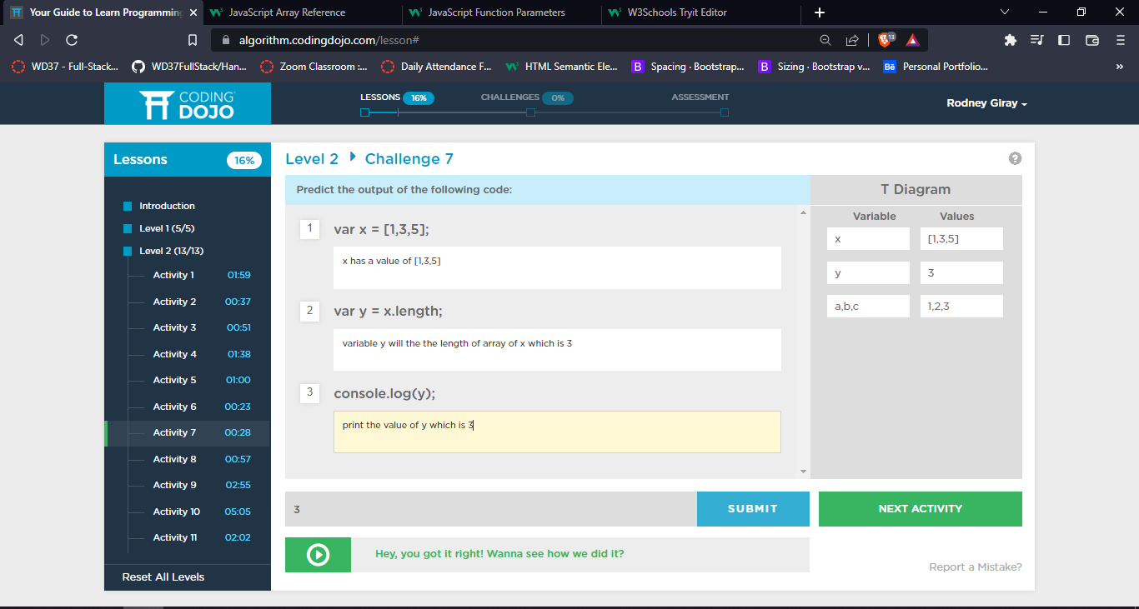

Level 2 Activity 8 – in this image it gives an idea that the length of array can apply an arithmetic operation.

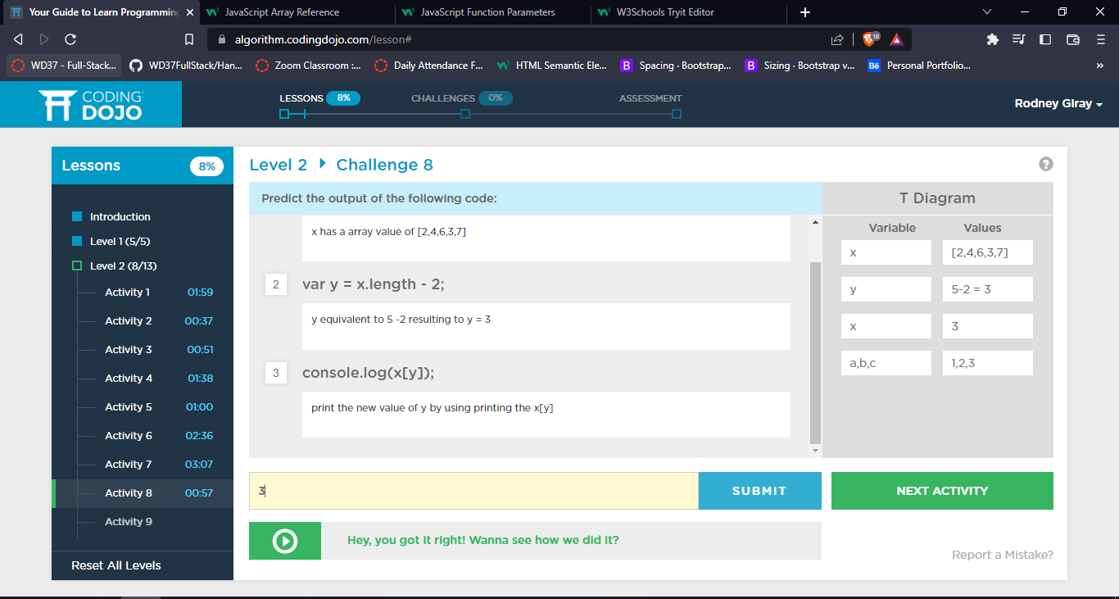

Level 2 Activity 9 – This activity it helps me to understand that it can perform arithmetic inside of console.log.

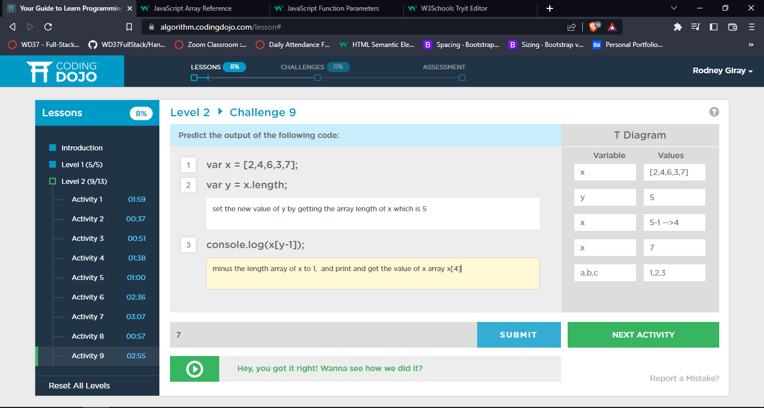

Level 2 Activity 10 – in this activity it will set the value for x[0] after reducing the length of array to 2 and set the new value for x.

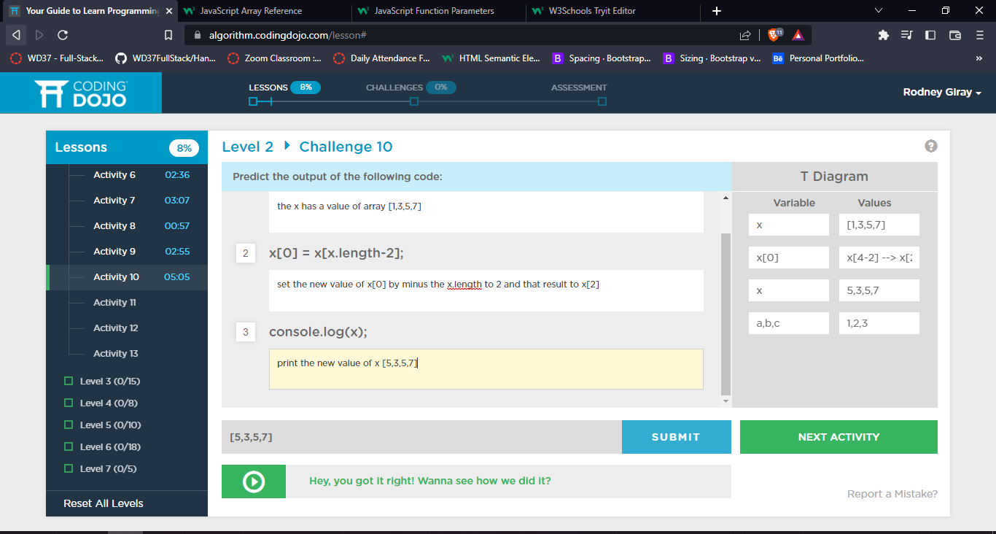

Level 2 Activity 11 – in this activity image I observed it getting complicated but if you really understand the array you can solve it.

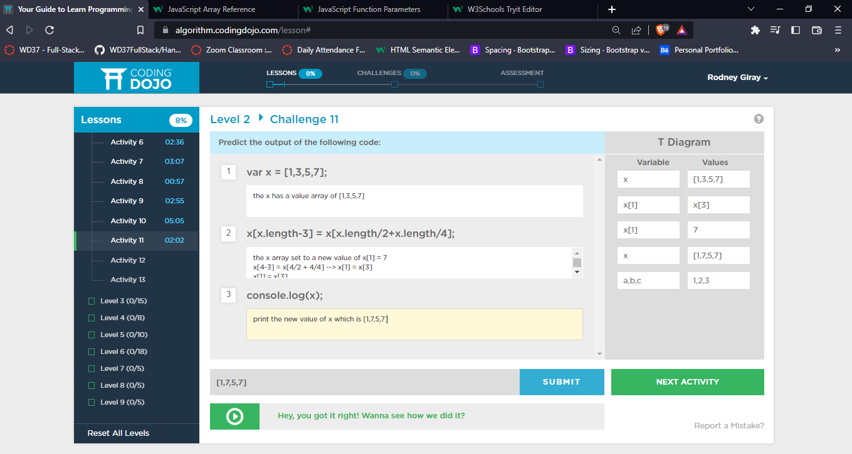

Level 2 Activity 12 – in this activity the x and y has an array value, the x[2] will set a new value of 4 after performing arithmetic operation for y variable.

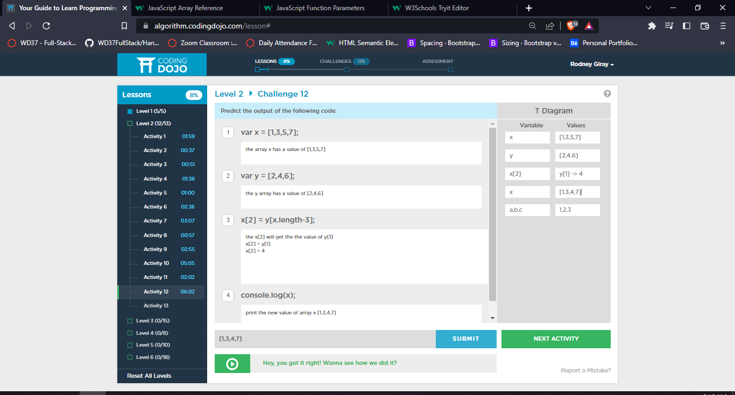

Level 2 Activity 13 – For this last activity of level 2 is same too activity 12, it is more complicated compare to the previous activities. The variable y will get the value after solving the arithmetic operation and it will set the value of x[2].

